Warrior Run
Transition
Program

Developed by:
Cathy Grow
Transition Coordinator
Warrior Run School District

Warrior Run Mission Statement:
It is the mission of the Warrior Run School District to provide an educational program in a safe environment that ensures students the opportunity to reach their fullest potential.

This mission statement is directly impacted by the successful transition of the special education population into their adult lives. Therefore, it is the mission of the Special Education Department at the Warrior Run School District to provide all Special Education students with services and activities that will enhance their education and provide the best possible post-secondary outcomes.

What is transition?
Transition planning assists youth with the exploration of opportunities and identification of goals for life after high school. In many ways effective transition planning is like a road map – it is a series of defined paths that lead to adult life as a destination. Such destinations for youth include education, employment, independent living, and health and wellness. It is equally important for you to know that transition planning for students is required by the Individuals with Disabilities Education Act (IDEA 2004) and Pennsylvania Special Education Regulations (Chapter 14). Transition planning for youth with disabilities needs to begin at age 14, or younger, if determined appropriate by the students’ Individualized Education Program (IEP) team. The transition planning process is based on individual students’ needs, strengths, preferences, and interests.

What area does transition planning cover?
Independent Living:
This domain covers the skills a person needs to function independently in life, and may include such areas as cooking, transportation, budgeting, safety, technology, housing, time management, social, etc.

Employment:
This domain covers skills necessary for many levels of employment (i.e. competitive, self-, customized, supported, sheltered). These skills may be in areas such as career exploration and matching, applying, being on-time, following directions, associating with colleagues, etc.

Post-Secondary Education:
This domain covers skills and preparation needed to attend a variety of post-secondary education settings (universities, community colleges, technical school, military, etc.). These skills may be in areas such as choosing a major, class selection, assignment completion, test-taking, organization, study skills, etc.
Topics that will be covered in this program:

Transition Assessments
Transition Assessments…………………………………………………………page 5
Warrior Run Career Readiness Program……………………………………..page 6
Questions to ask before an IEP meeting……………………………………...page 10
Goals and Objectives……………………………………………………………page 11

Work Internships
Work Internship businesses……………………………………………………page 13
Work Internship forms that needed to be completed…………………….....page 14
Student’s Work Internship Evaluation...……………………………………...page 15
Work Internship grades………………………………………………………...page 15
Transportation…………………………………………………………………..page 16
Work Internship absences……………………………………………………..page 16
Scheduling………………………………………………………………………page 17
Early dismissals and school delays…………………………………………..page 18
Injuries on the job………………………………………………………………page 18
Process of starting an internship……………………………………………..page 19
Work Internship paperwork:
Liability/Confidentiality form…………………………………………..page 21
Professional Work Experience Training Agreement………………page 22
Supervisor Visitation Evaluation……………………………………..page 25 Emergency Form………………………………………………………page 26
Job Coach Daily Report ……………………………………………...page 27
Fading Plan…………………………………………………………….page 29
Work Internship Progress Report……………………………………page 31
Employee Satisfaction Survey……………………………………….page 32

Transition Clinics
Transition Clinics ……………………………………………………………..page 33

Transition Conference
Transition Conference………………………………………………………..page 34
Transition Activities
Group presentations by OVR……………………………………………….page 35
P.E.T.S. Program…………………………………………………………….page 35
Parent Vocational Trainings…………………………………………………page 35

Defenders’ Café
Defenders’ Café purpose…………………………………………………… page 36
Defenders’ Café Vocational Skills Taught………………………………….page 37
Job Skills Checklists……………………………………………….....page 38
Defenders’ Café paperwork……………………………………………….....page 46
Defenders’ Café profits……………………………………………………….page 47
Defenders’ Café Invoice …………………………………...………………..page 48
Defenders’ Café Cash In/Out Log..………………………………………...page 49
Defenders’ Café Weekly Deposit Log………………………………………page 50

Transition Assessments

What are transition assessments?
The Division on Career Development and Transition (DCDT) of the Council for Exceptional Children defines transition assessment as an “…ongoing process of collecting data on the individual’s needs, preferences, and interests as they relate to the demands of current and future working, educational, living, and personal and social environments. Assessment data serve as the common thread in the transition process and form the basis for defining goals and services to be included in the Individualized Education Program (IEP)” (Sitlington, Neubert, & LeConte, 1997; p. 70-71). Federal law requires “appropriate measurable postsecondary goals based upon age appropriate transition assessments related to training, education, employment, and, where appropriate, independent living skills” (§300.320[b][1]).

All students identified as Special Education must have yearly transition assessments in the areas of employment and independent living that must be identified in the transition grid and are linked specifically with goals and objectives. The data collected from the results of these transition assessments along with any other set of coordinated transition activities must be summarized and documented in the Present Levels Transition section in the IEP and also documented when an Evaluation or Re-evaluation occurs. In the Present Levels Transition section, each of the transition activities and results of transition assessments and data collected from transition IEP goals and objectives should be shown in a running record that continues on to each of the IEP’s from the time the student is turning 14 to age 21.

*COPIES OF TRANSITION ASSESSMENTS ARE LOCATED IN THE TRANSITION COORDINATORS OFFICE, ALONG WITH LISTS OF POSSIBLE ASSESSMENTS BASED ON DISABILITY CATEGORY AND/OR GRADE.

*A WEBSITE THAT CAN BE USED AS A RESOURCE:
http://www.iidc.indiana.edu/styles/iidc/defiles/CCLC/transition_matrix/Transition_Matrix.html

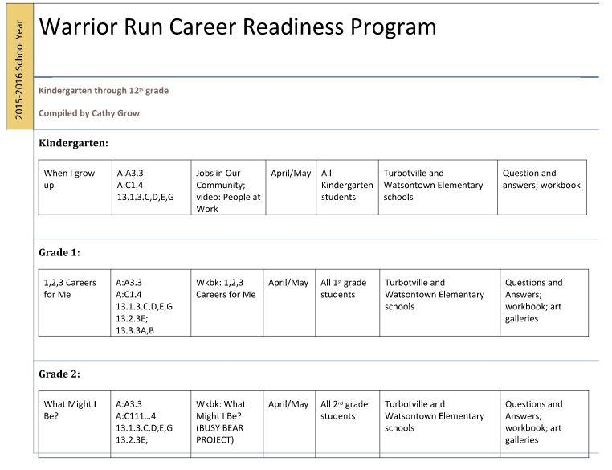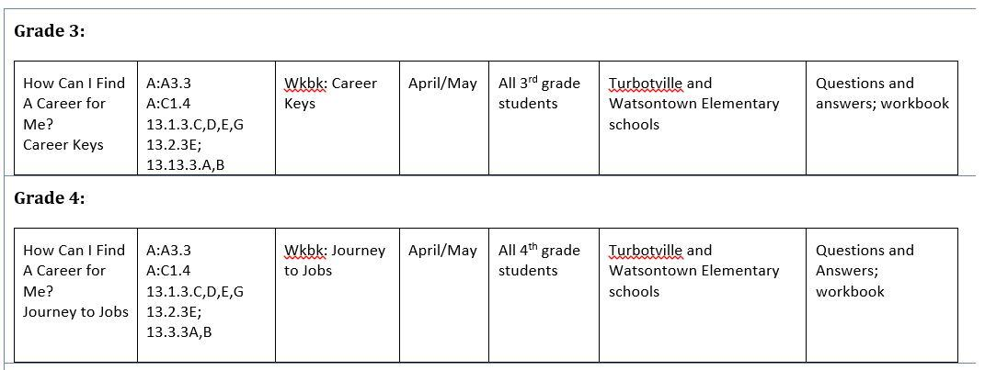

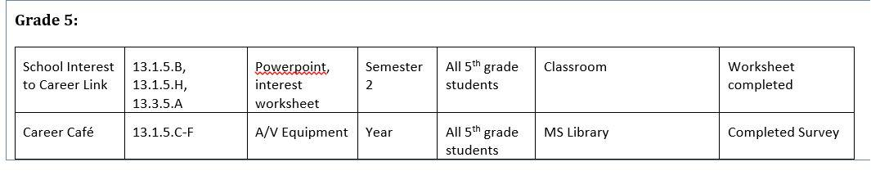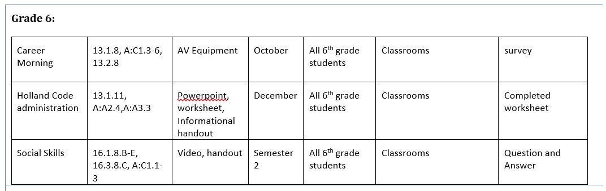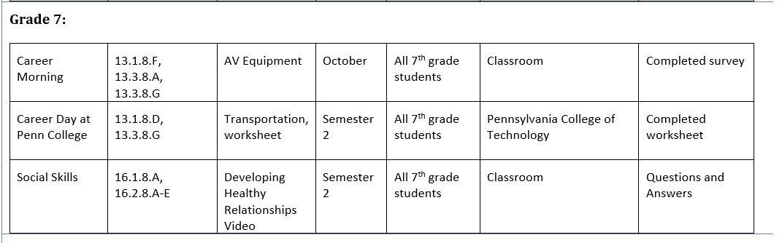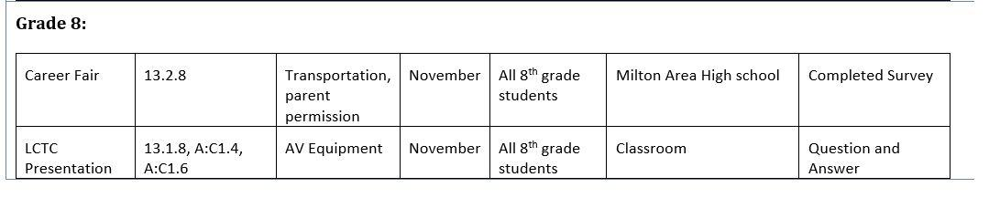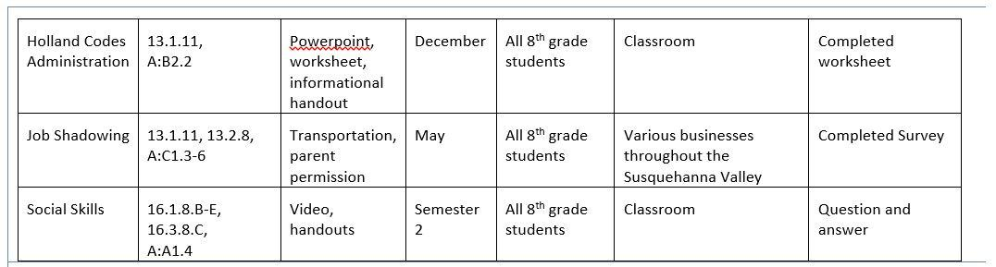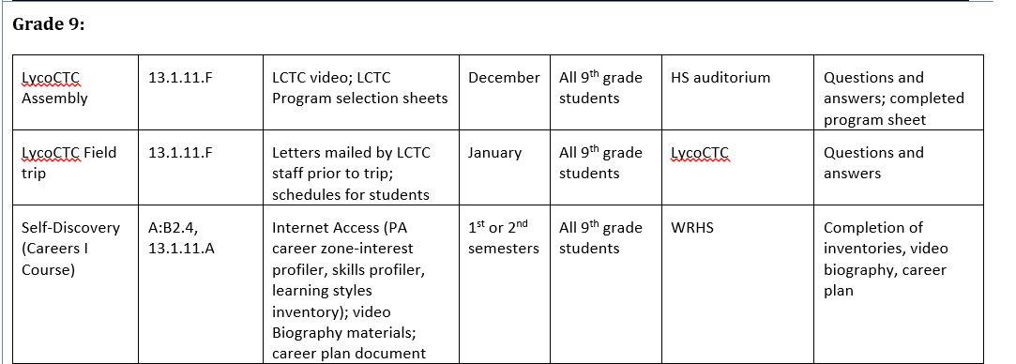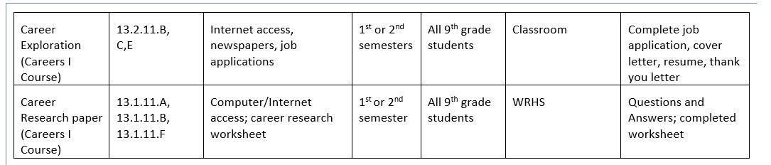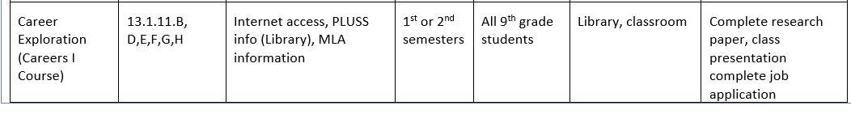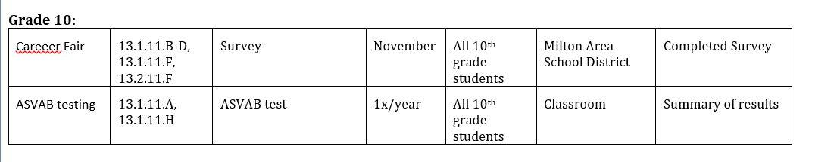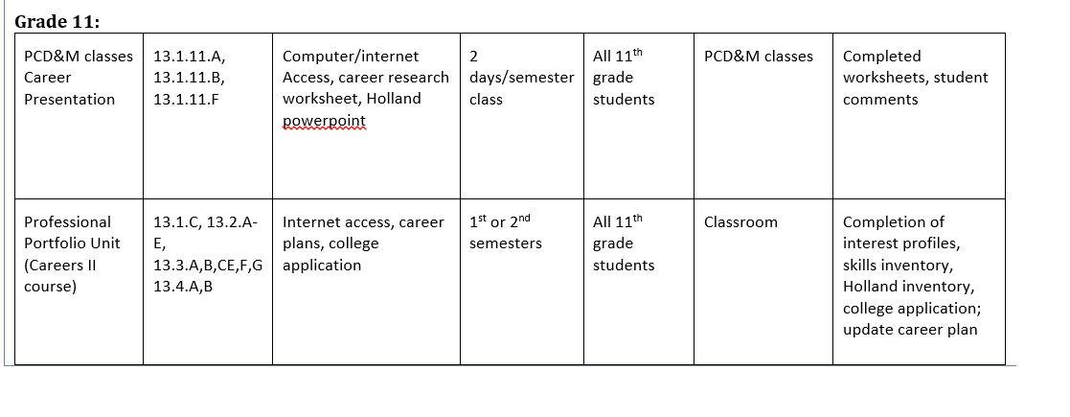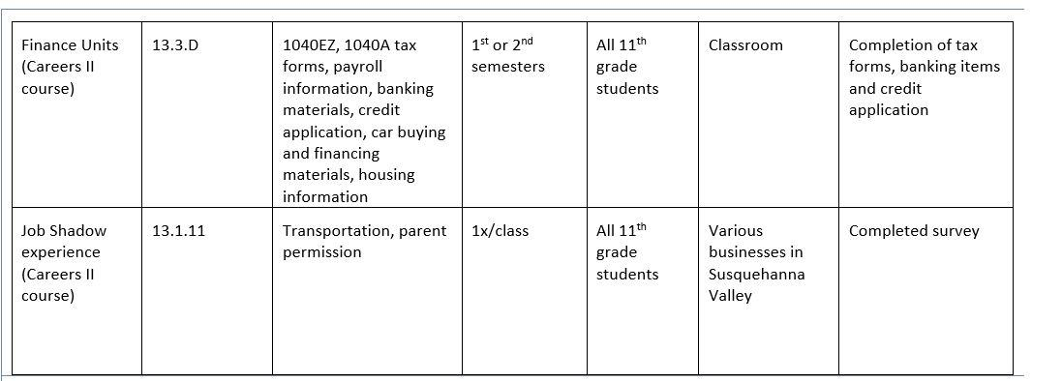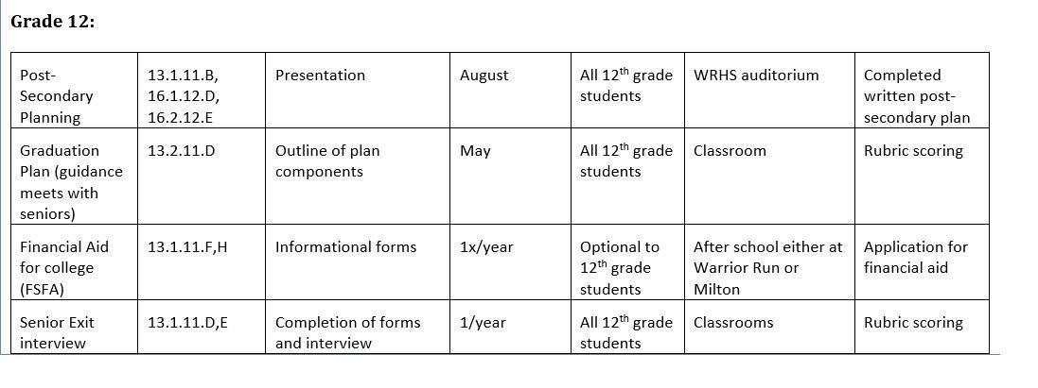
Other activities that occur:
-military recruiters at lunch cycles
-college representatives in the guidance office
-Juniornet and seniornet emails sent to students by guidance counselors
-Driver’s Education Training for all 10th grade students
-Pathways career paths identified by students starting in 9th grade: Arts and Humanities; Business, Communication and Informational Technology; Engineering, Manufacturing and Industrial Technology; Human Services; Science and Health
-Transition clinic and Transition Conference for Junior Special Education Students
-work internship opportunities for Junior and Senior Special Education students
-monthly vocational topic presentations for Special Education students

*The Warrior Run Career Readiness Program is subject to curricular changes during any given school year.

Questions to Ask Students before an IEP meeting:

Employment:
What kind of work would you like to do?
What kind of training will you need for that work?
What kind of environment would you enjoy working in?
Will you need any supports on the job?

Postsecondary Education:
Are you interested in pursuing higher education after you leave high school?
Have you investigated the types of colleges/universities that would match your interests/needs/environment?
What supports will you need to succeed in a postsecondary, academic environment?

Independent Living:
Where would you like to live (with your family, on your own, with a friend)?
What kinds of skills will you need to make it happen (cooking, cleaning, using transportation)?
How will you take care of your health needs?
How will you manage financially?

Community Participation:
Will you be able to travel to work and pursue leisure activities in the community?
Will you be able to access the services that can help you?
Do you have hobbies and interests outside of school? Will they be enough to fill your leisure hours as an adult?
How will you be able to find friends and maintain relationships with friends and family?

Once you have the answers to some of these questions, you can begin to develop a framework for what life after school will look like for this student. You will also have a better idea of what skills, experiences, and educational experiences must be integrated into the student’s IEP.

(information provided by: http://ctserc.org/transition/trans-goals-obj.pdf?2fa6f942252db2ec6c621fe255459617=b7e8cc207d4712688c730eeea7fcdbef )

Transition Goals and Objectives
Within each of the four outcome areas, check all activities that have been considered in the development of the student’s transition goals and objectives.
Post Secondary Education
Does the student’s IEP include consideration of:
- Enrollment in College Preparatory courses;
- Accommodations to meet general education course requirements;
- Minimizing or eliminating curriculum modifications over four years of high school;
- Teaching of learning strategies that are appropriate to student needs and include study skills, time management and organizational skills;
- Participation in college entrance examinations, with appropriate accommodations;
- Exploration of a variety of college choices to ensure that there is an appropriate match and that support services are available to meet the needs of the student;
- Obtaining financial aid and/or scholarships;
- Teaching self-advocacy skills so the student can articulate learning strengths and weaknesses and share information with others;
- Development of postsecondary education goals and objectives that includes student/family input;
- Development of social skills;
- Linkages to state agencies/community resources, if appropriate;
- Utilization of Assistive Technology, if appropriate.
Employment
Does the student’s IEP include consideration of:
- Enrollment in the highest level of academic coursework to ensure students are gaining the skills to advance to the best career opportunities
- Supporting and enhancing the skills required to be successful in a variety of employment settings through school curricula
- Enrollment in coursework to enhance skill development in technologies (business, computers)
- Sequencing of employment curricula from career awareness to career exploration to specific skills training that matches interests and preferences
- Movement of career training experiences from in-school to community-based settings
- Exposure to appropriate workplace behaviors (task persistence, punctuality, effective communication)
- Workplace accommodations, if appropriate
- Teaching self-advocacy skills so the student can articulate learning strengths and weaknesses and share information with others
- Development of employment goals and objectives that includes student/family input
- Development of social skills
- Linkages to state agencies/community resources, if appropriate
- Utilization of Assistive Technology, if appropriate.
Independent Living
Does the student’s IEP include consideration of:
- Enrollment in curricula that addresses:
  - Personal/legal advocacy
  - Personal Finance Management
  - Household selection and management
  - Daily Living skills
  - Family Planning/Sex Education
  - Nutrition
  - Consumer Skills
  - Personal and health insurance
  - Managing individual health care and medical needs in all environments;
- Providing skills training in a community-based setting, if appropriate;
- Participation of all appropriate pupil personnel and general education staff who could support the student in independent living skills development;
- Teaching self-advocacy skills so the student can articulate learning strengths and weaknesses and share information with others;
- Development of independent living goals and objectives that includes student/family input;
- Development of social skills;
- Linkages to state agencies/community resources, if appropriate;
- Utilization of Assistive Technology, if appropriate.
Community Participation
Does the student’s IEP include consideration of:
- Participation in extracurricular activities (clubs, sports);
- Use of transportation options: independent, public, specialized;
- Need for travel training;
- Participation in community recreation/leisure activities;
- Strengthening of friendships/relationships;
- Voting and citizenship;
- Inclusion in social groups/clubs;
- Volunteering;
- Providing skills training in a community-based setting, if appropriate;
- Teaching self-advocacy skills so the student can articulate learning strengths and weaknesses and share information with others;
- Development of community participation goals and objectives that includes student/family input;
- Development of social skills;
- Linkages to state agencies/community resources, if appropriate;
- Utilization of Assistive Technology, if appropriate.
Developed by the Connecticut Transition Task Force Parent Sub-Committee, 2005
Click to download a PDF of “Transition IEP Goals, Objectives and Services Checklist

Work Internships

Special Education students in their junior and senior year are eligible to be placed into work internships. Priority is given to students who are currently about to begin or in their senior year. All work internship placements are determined by the IEP team with the following criteria being a focus for that decision: need of vocational skills, social skills, and/or independent living skills; the possible inability to obtain employment on their own; has shown difficulty in remaining employed; has a desire to be placed in a work internship; and/or a student has identified needs that can be addressed by a placement in the Work Internship Program.

Businesses currently accepting students:
Businesses | Contact Person
Salvation Army

Bonanza
Cole’s Hardware

CSIU Pre-K Counts
Milton YMCA
Blaise Alexander
Phoenix Rehab
Earl’s Bicycle Shop
Spencer’s Chrome
Montgomery House Library
CSIU Northumberland County Head Start
Rovendale Ag

Students are also able to be placed in work internships throughout the school district in various positions.

The Transition Coordinator is responsible for speaking with businesses prior to the beginning of the school year to obtain work internship possibilities for students. The list above may change depending on the addition of possible work internship placements with other businesses. Warrior Run is currently seeking work internship placements for students in the following areas, as identified by the Central Pennsylvania Workforce Development Corporation (CPWDC) as high priority occupations: Advanced Materials/Diversified Manufacturing, Education, Energy, HealthCare, and Lumber, Wood, and Paper.

Warrior Run currently does not provide a stipend for students who are in work internship placements. Students receive 3 credits at the end of the school year for successfully completing the year-long placement. Students do not have to remain in the same work internship placement for the entire year but must remain in the program. Students are monitored by the Transition Coordinator and Job Coaches to ensure their successful employment and to determine if possible changes are needed.
To remain in the Work Internship Program students must:
● Students must maintain a good working relationship with their employer, which
will be tracked by documentation through the Transition Coordinator or Job
Coach.
● Students must be passing all subjects, unless students are continuing to improve
their grades and the teacher of the class approves of their continuation in the
program.
● Students must show appropriate behavior at school and during work internship
placement.
● Students must follow all rules and regulations set forth by the business where
a student is placed, which includes: dress code, clearances, physical
requirements, and work standards for maintaining safety.
● Students must communicate with the Transition Coordinator in instances where
a student feels unsafe, observes possible criminal activity, harassment by others,
discrimination of any kind, feels that the work internship placement is not helping
to reach their post-secondary goals, and/or has any concerns with supervisor(s),
coworkers, or any other individuals that they may come in contact with during
their work internship.

What forms need to be completed in order to be placed in a work internship?
● Professional Work Experience Training Agreement
-signed by student, parent(s)/guardian(s), Transition Coordinator, and
business representative
● Internship Permission Slip
-signed by parent(s)/guardian(s)
● Emergency form
● Clearance forms (depends on business requirements)
-Child abuse, Criminal, FBI
● Copy of Health Insurance Card
● Physical Form (depends on business requirements)
● Possible IEP revision to include work internship
● Parent permission slip (for entire school year) to attend field trips
● Working Papers (completed in high school office)
● Any other paperwork deemed necessary by business requirements

How are students evaluated?
Students, who are placed in work internships, will be closely monitored to ensure that they learn the skills needed to become successful employees in the businesses that they are working in. Supervisor(s) will be asked to complete a questionnaire based on the student’s performance at least biweekly. This information will be compiled by the Transition Coordinator and will be used to give a student a grade for the work placement. Grades will be given based on 5 questions that indicate the student completes each of the areas all of the time, most of the time, or needs improvement. The five areas observed are:
- Following directives
- Time management
- Dress code and appearance
- Behavior
- Respect
As well as, skills that need to be worked on and opportunity to provide comments.

The responses to this documentation is then submitted onto an excel spreadsheet and a grade based on the answers given is documented on the report card.

How are students graded on their evaluations?
Students are graded based on their evaluations completed by their supervisor(s). If students receive an “all the time” response on their evaluation form then they receive an “A” letter grade which is equivalent to a 95%. Students who receive “most of the time” on their evaluation form then receive a “B” letter grade which is equivalent to an 85%. Students who receive “needs improvement” on their evaluation form then receive a “C” letter grade which is equivalent to a 75%. All of the percentages gathered during a visit will be averaged to receive an overall percentage for that visit. Those percentages, for each visit during the marking period, are then averaged to receive the marking period grade. Students receive a 60% that is counted as 50% of their marking period grade if they are fired from their placement or decide that they want to quit the program. Students who are fired from a business that they are currently placed will be placed into another business at the discretion of the IEP team, unless the behavior went against school policy and required immediate disciplinary action by the school district. If students do not follow the contract that was signed at the beginning of the work internship placement, then students can be suspended or removed from the program.

How are students transported to work placements?
Students who are scheduled to attend work at 8:00am will be transported using the school district’s contracted busing company. Students will be picked up at their home and transported to their work internship placement.

Students who are either dropped off or picked up during school hours will be transported by district vehicles by school district employees. District employees must present the Business Office a copy of their driver’s license for insurance purposes. District employees will drive district vehicles to transport students during the school day.

Students who end their placement at 3:00pm will be transported using the school district’s contracted busing company from their work internship placement to their home.

All busing arrangements will be made by the Transition Coordinator and the Supervisor of Special Education, along with the owner of the contracted busing company that the school district uses. The Transition Coordinator will notify the bus company owner of any changes that need to be made to the transportation schedule (ex. student illness, discontinuation of placement, any addition to a student’s schedule, etc.).

What do I do if my child is sick?
If a student will not be able to attend their work internship placement for any reason, the parent(s)/guardian(s) must notify the Transition Coordinator prior to the start of their work day. The Transition Coordinator will then notify the bus company owner, the business supervisor, and the school district attendance office. Students who do not call off to the Transition Coordinator, prior to their work day, can be removed from their work internship placement and receive a failing grade for their work internship placement for the marking period.

Parent(s)/Guardian(s) will be asked to sign a “year-long” permission slip that allows their child to be transported by school district employees during their work internship and also allows their participation in all work internship activities; such as, incentive field trips, vocational visits, visitations to other programs/districts, etc.

Important numbers:
Transition Coordinator: Cathy Grow Phone: (570)649-5138 ext. 4022
Supervisor of Special Education: Julie Petrin Phone: (570)649-5138 ext. 5010
High School Principal: Marc Walter Phone: (570)649-5138 ext. 4000
Secretary to the Principal: Michelle Leitzel Phone: (570)649-5138 ext. 4002
Secretary to Supervisor of Special Education: Caryl Moser
Phone: (570)649-5138 ext. 5011

How does a work internship fit into my child’s schedule?
The possibility of placing a student into an internship first starts with the Transition Coordinator looking at the student’s needs, grades, credits and positions available or possibility of a business excepting a student. For example, if a student wants to participate in a work internship and a placement is available, then it needs to be determined if the student has enough credits to graduate with the work internship in their schedule. It is a possibility that a student will not be able to participate in a work internship program because the student needs to be in school in order to complete their academic courses to graduate based on credits. However, if a student does not desire to go to a 4-year college program, then the student could graduate based on IEP goals and still participate in a work internship. The decision to graduate a student based on credits or IEP goals needs to be decided by the IEP team.

The Guidance Counselor will be included in the IEP team decisions so that the student’s schedule and transcript can be viewed and an informed decision can be made to continue planning the work internship placement. The Guidance Counselor will provide the parent(s)/guardian(s) and student with a schedule so that the placement of academic classes can be determined.

A student who is scheduled for work internship in the morning will return to a study hall upon returning to school and then be scheduled for lunch. Students who attend a work internship in the afternoon will eat lunch at school before leaving. Any questions about scheduling should be addressed to the guidance counselors.

What happens during early dismissals and school delays?
Students who are to report to work in the morning, but the district has a delay, will report to school and will not go to work. Students will then report to study halls and will be given a soft skills vocational workbook to complete during study halls by the Transition Coordinator. The students will then return the workbooks to the Transition Coordinator at the end of the day.

Students who are to report to work in the afternoon, but the district has an early dismissal, will not attend work.

Students that do not go to work internship placements for any reason will be placed in study halls and be provided with soft skills vocational workbooks to complete. This workbook will be provided to the students by the Transition Coordinator.

Work internships always follow the Warrior Run School District school calendar.

What happens if your child is injured on the job?
Businesses that have Warrior Run students placed at their work sites will be provided with an Emergency Form that includes important information; such as, parent/guardian contact information (phone numbers and address), phone numbers and address for the Transition Coordinator, as well as the names, phone numbers and address for the Supervisor of Special Education, Special Education Secretary, High School Principal, and school district bus company. Business’ supervisors are instructed to contact the Transition Coordinator immediately if any students require medical attention, unless there is an immediate need to call 911. The Transition Coordinator will then call the parent(s)/guardian(s) to relay the situation and formulate a medical plan, whether it is to transport the student to the school nurse or take the student to the emergency room.

All jobs carry risk of injury; therefore, students will be instructed on how to properly operate equipment and complete vocational tasks in a safe manner.

What is the process of starting a work internship program?
- The Transition Coordinator will review transition assessment results of students and speak to Special Education Teachers of record to determine which students would benefit from a work internship placement.
- The Transition Coordinator will speak to the student about the possibility of participating in the work internship program, and if the student is interested, then the Transition Coordinator will continue with the process.
- The Transition Coordinator will go to the Guidance Counselor to discuss grades, credits, and whether an internship placement would fit into the student’s school schedule and talk about whether the student would need to graduate based on credits or IEP goals.
- The Transition Coordinator will determine if a work internship placement currently exists for that student, and if not, the Transition Coordinator will go to businesses that are of interest to the student to possibly set-up a partnership with the business.
- Once a work internship placement is available, the Transition Coordinator will call the parent(s)/guardian(s) to explain the program and the opportunity available and determine a date and time to have an IEP meeting with the Supervisor of Special Education, Guidance Counselor, Transition Coordinator, parent(s)/guardian(s) and student.
- During the IEP meeting, parent(s)/guardian(s) will be shown the prospective schedule, discuss graduating based on credits or IEP goals, review the policies and regulations of the business that the student would be working for, sign the contract “Professional Work Experience Training Agreement” and the “Permission Agreement” to participate, complete working-papers application in the office, provide a copy of the student’s health insurance card, be given applications for clearances (if needed), and review policies of the work internship program.
- The Transition Coordinator will schedule a “meet and greet” with the prospective employer, in order to give the student interview experience. During this meeting, the student will be given a tour of the business, review policies and expectations, and the business supervisor will sign the “Professional Work Experience Training Agreement”, as well as be provided with a copy of the “Permission Agreement” signed by the parent/guardian. The Transition Coordinator and the business supervisor will determine a start date for the student.
- Parent(s)/Guardian(s) are notified that all of the paperwork is complete and that a start date was determined.
- The Transition Coordinator notifies the High School Principal, Supervisor of Special Education, Principal’s Secretary and Guidance Counselor of the student’s start date and hours the student will be working.
- The Transition Coordinator notifies either the busing company or the high school driver about pick-up and drop-off times.
- The Guidance Counselor notifies the student’s teachers of the schedule changes and gives the student a new schedule before the start date.
- The Transition Coordinator instructs students on how to sign-in and sign-out of school to attend work.

After going through this process, students are ready to begin their work internship program. All questions should be directed to the Transition Coordinator.

WARRIOR RUN SCHOOL DISTRICT

SPECIAL EDUCATION
Dr. Alan Hack
Superintendent
Heather N. Burke
Business Manager
4800 Susquehanna Trail
Turbotville, PA 17772
570-649-5138
Julie Petrin
Special Education Supervisor
Cathy Grow

Transition Coordinator

Dates of Service:__________________________
Dear Parent(s)/Guardian(s),

The transition program in the Warrior Run Area School District encourages students to participate in job shadows, mentorships, and internships with employers in the local community. Permission is required from parents/guardians to consent to these opportunities as they occur within your child’s program. Warrior Run transition staff including paraprofessionals and the transition coordinator will transport, supervise (assisted or unassisted), and evaluate your child within the community at their potential job site.

Departure and arrival times will vary by employer need and by your child’s schedule (Per the “Warrior Run Professional Work Experience Training Agreement”). Prior notice for each trip will be sent home weekly to notify you of the impending trip and the requirements for that job site.

Additionally, school based trips will be made to local grocers to shop for the coffee cart, community based trainings, and other transition related activities. Warrior Run transportation will be provided.

Please sign and return the following form, acknowledging the risks involved and the assumption of responsibility to all your child’s participation.

Authorized to Treat Minor: In the event that I cannot be reached in an emergency, I hereby
permit to call 911 and/or to contact a medical facility or physician selected by the School to
provide proper treatment to my child and that I will be responsible for all expenses arising in association with such treatment. Parent Initials:________________
Prescription or Over the Counter Medication: I certify that I have on my file in the
School office, a current profile enlisting necessary medications that my child must take. Parent Initials________
Acknowledgment of Notification Regarding Risk: I hereby acknowledge that I have
been notified whether or not the activities involved in this field trip are considered to be of "high risk" to the participants. I agree to assume all risk associated with the Student participating in the Professional Work Experience Training program.
Parent Initials:_____________
Indemnity and Waiver of Claim: I, the undersigned, the Parent /Lawful Guardian of _______________hereby acknowledge that as a condition of the Student participating in the activity, agree to indemnify and hold harmless the School, its employees and volunteers, the Warrior Run Area School District, its governing board, the individual members thereof, and all other district officers, agents and employees from any liability, lawsuit, cost, expense or claim of any type whatsoever (including legal fees) for any harm, injury or death arising out of the above mentioned activity.
Parent Initials:___________

Release of Information: I hereby give permission for the tentative employer to have access to information about my child related to medical issues, disability, strengths, weaknesses, and behavioral issues. Parent Initials:_____
Parent(s)/Guardian(s) Signature: _________________________ Date:______________
Student Name:_____________________indicates that you agree to your child’s participation in the transition program and the requirements outlined above.

Professional Work Experience Training Agreement
Warrior Run School District
4800 Susquehanna Trail
Turbotville, PA 17772

Student Name ________________________ Job Title ___Activity Volunteer____
Address _______________________________________________________________________
Phone (____)___________ Cell Phone (____)_____________ Email: ___________________

Company Name __ _____________________________________________
Supervisor Name and Title __________________ : Position _________________________
Address ______________________________________
Phone _______________________________________

Agreement begins: _____________________Agreement ends: ______________________

General Criteria:
- The internship is for the benefit of the student-learner.
- The student-intern does not displace regular employees but works under their close observation.
- The business understands that the business does not derive any immediate advantage from the activities of the student-learner and on occasion, its operations may actually be impeded.
- The student-intern is not automatically guaranteed a job at the conclusion of the internship period.
- The business and the student-intern understand that the intern is/is not entitled to wages and shall not receive the same for the time spent in training.
- A student-intern who is released from the internship by the site supervisor/mentor for a justified reason may be dropped from the program.
- The site supervisor/mentor and the school will provide instruction and experiences at the internship site and in the classroom that will provide the student-intern with skills and attitudes necessary for life-long learning, competitive employment and continuous improvement.

The Student-Intern agrees to:
- Perform the necessary tasks and follow instructions as given by the internship coordinator and/or business supervisor/mentor.
- Abide by the regulations and policies of the business and the school.
- Attend the related class as required.
- Notify the internship coordinator and the site supervisor/mentor on days absent or late prior to starting time (when possible).
- Not report to the internship site on days absent from school
- File complete weekly reports on his/her activities as required.
- Report to the internship coordinator as soon as possible when problems arise affecting his/her internship placement.
- Study the student handbook and accept the conditions set forth therein.
- Not hold the internship site liable for accidents or injuries sustained during training.
- Dress appropriately for the school-related program as well as the internship.
- Provide proof of medical insurance.
- Support all activities related to the internship program.
- Refrain from using a personal cell phone for text messaging and/or personal calls.
- Refrain from using computer/technology for email, chats and any other personal communication.
- Keep all matters confidential.

The Business agrees to:
- Assign a training supervisor who will evaluate and supervise the student-intern as agreed upon.
- Provide training that will meet a pre-approved training plan.
- Meet with the internship coordinator at periodic intervals to discuss the student-intern’s progress.
- Notify the internship coordinator in advance if plans are made to terminate or alter the position of the student-intern.
- Provide safety instruction for all tasks and duties to be performed that may present a possible safety hazard to the student-intern.
- Provide compensation for any work done beyond the regular hours of the internship and only for said work beyond the regular hours.
- Comply with all student intern applicable state and federal employment regulations, provide student-intern with equal opportunity employment and not discriminate on the basis of race, color, national origin (including limited English proficiency), sex or handicapping conditions.
- Adhere to the provisions of all state and federal child labor laws.
- Evaluate the student-intern.

As a Training Agency we also understand and agree to abide by the following:
- All U.S. Department of Labor regulations for non-paid vocational training sites and Child Labor Laws shall be followed. These included:
  - The training, even though it included the actual operation of the facilities of the training agency, is similar to that which would be given in a vocational education program.
  - The training is for the benefit of the student trainee(s).
  - The student trainee(s) do not displace regular employees but work under their close observation.
  - The training agency derives no immediate advantage from the activities of the student trainee(s), and on occasion, operations may be impeded.
  - The student trainee(s) is/are not necessarily entitled to a job at the conclusion of the training period.
  - The student trainee(s) is/are not entitled to wages for the time spent in training.
  - The training experience is part of the student trainee’s educational plan.
  - The student trainee(s) will be under the direct supervision by school or training personnel.

Warrior Run School District agrees to:
- Administer the program and provide necessary forms: Contract and evaluations
- Provide specific and/or general related instruction.
- Act as liaison between the parties of this agreement.
- Provide transportation during school hours
- Maintain adequate records.
- Notify the site supervisor/mentor in advance if the training status of the student-intern changes (when possible).
- Make periodic contacts with the site supervisor/mentor to discuss student-intern’s progress and to evaluate the training site.
- Evaluate the student-intern.

The Parent or Guardian agrees to:
- Direct the student-intern in carrying out his/her responsibilities and to contact the internship coordinator, NOT site supervisor/mentor, when problems or questions arise concerning the student-intern’s internship.
- Provide insurance for the student-intern.
- Not hold the business or Warrior Run School District liable for any accidents or injuries sustained during the internship.

_________________________________________________________ _________________________
Student-Intern Signature Date

_________________________________________________________ _________________________
Parent/Guardian Signature Date

_________________________________________________________ _________________________
Site Supervisor Signature Date

_________________________________________________________ _________________________
Internship Coordinator Signature Date

It is the policy of the Warrior Run School District not to discriminate on the basis of race, color, religion, gender, veteran status, national origin, age, limited English proficiency or disability in its programs or employment policies as required by the Indiana Civil Rights Law (I.C.22-9-1), Title VI (Civil Rights Act of 1964), The Equal Pay Act of 1973, Title IX (Educational Amendments) and Section 504 (Rehabilitation Act of 1973).

Work Internship~ Supervisor Visitation Evaluation:
Student's WORK INTERNSHIP
Is Student following the dress code and his appearance is neat and tidy?
Does Student complete his work in a timely manner?
Is Student's behavior appropriate for the work environment?
Is Student following the directives given by the supervisor(s)?
Is Student respectful to supervisor(s), coworkers, and anyone else he comes in contact with?
What are some skills that Student needs to work on?
Any other comments that you feel are relevant?
Does Student ask for help when he needs it?
  - yes
  - no
Does Student finish a task and then goes to another task independently?
  - yes
  - no
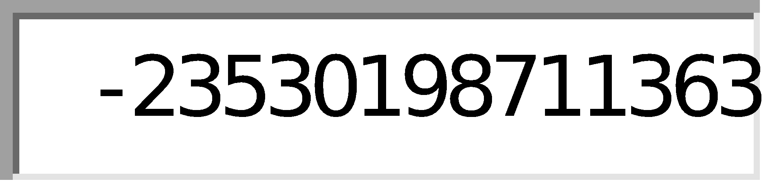

WARRIOR RUN SCHOOL DISTRICT
SPECIAL EDUCATION
Dr. Alan Hack
Superintendent
Heather N. Burke
Business Manager
4800 Susquehanna Trail
Turbotville, PA 17772
570-649-5138
Julie Petrin
Special Education
Supervisor
Cathy Grow

Transition Coordinator

Emergency Form

Student: ___________________
Parent: ___________________
Address: ___________________
home number: ___________________
work number: ___________________
Cell number: ___________________

WR Transition Coordinator: Cathy Grow
Cell phone number:
Work number: 570-649-5138 ext. 4022
Email address: cgrow@wrsd.org

Transportation to work: Will Murray
Cell phone number:

Warrior Run Supervisor of Special Education: Julie Petrin
Work number: 570-649-5138 ext. 5010
Email address: jpetrin@wrsd.org
Secretary for the Supervisor of Special Education: Caryl Moser
Work number: 570-649-5138 ext. 5011

Warrior Run School District address: 4800 Susquehanna Trail
Turbotville, PA 17772
Warrior Run High School office and Principal’s secretary: Michelle Leitzel
Work number: 570-649-5138 ext. 4002
Email address: mleitzel@wrsd.org

Job Coach Daily Report
Participant’s Name: _________________ Employment Position: _____________________

Job Coach: ____________________ Employer/Supervisor: ____________________

Date of Report: ________________ Work Schedule: __________________________

Date: | Time: | Length: | Methods and Activities and Progress
Date: | Time: | Length: | Methods and Activities and Progress:
 |  | Total Hours:

Date: | Independent Tasks: | Dependent Tasks:

Fading Plan

Student Name: | Work internship placement: | Job Coach:
Student performs these skills independently:

Date Date Date Date Date Date Date Date Date Date
Areas of current support:

√ = completed task independently
/ = required job coach support

Work Internship Progress Report
Name: _____________________________ Supervisor(s)__ ___________________________
Job site location:_______________________________________________________________________

Reporting Period:_____________________________ Job Hours:______________________

Additional training issues or concerns that are required for this student to maintain or improve employment:
Employment related issues or barriers addressed to enhance success on employment site
(work skills, transportation, health, assisted needs, or other concerns):

RATING SECTION | EXCELLENT | GOOD | AVERAGE | POOR
Quality of work
Rate of progress
Dependability
Ability to work with others
Personal appearance / hygiene
Willingness to learn various tasks and duties
Attitude
Listening skills
Ability to follow rules on job site /procedures
Respects Supervisors and other coworkers
Completes tasks independently
Additional comments:

______________________________________________________________________________

______________________________________________________________________________

______________________________________________________________________________

______________________________________________________________________________

WARRIOR RUN INTERNSHIP NETWORK
EMPLOYER SATISFACTION SURVEY 2016/17
We are committed to monitoring and evaluating the quality and service we provide, as part of an ongoing improvement process. We would appreciate your feedback on our performance.
For each item identified below, circle the number
to the right that best fits your judgment.
Use the rating scale to select the quality number.
Survey Item | Scale
 | Poor | Good |  |  | Excellent
- Did we do a good job educating you about our services? | 1 | 2 | 3 | 4 | 5
- Have you had positive interactions with the Warrior run Internship supervisory staff? | 1 | 2 | 3 | 4 | 5
- Have you had productive interactions with the Warrior Run Internship Job Coaches? | 1 | 2 | 3 | 4 | 5
- Do Warrior Run Internship Job Coaches follow your workplace practices? | 1 | 2 | 3 | 4 | 5
- Do we do a good job providing supports/services to you as the employer? | 1 | 2 | 3 | 4 | 5
- Do you feel that the Warrior Run supervisory staff handled problems appropriately, when they arose? | 1 | 2 | 3 | 4 | 5
- Are supports/services provided at a time that is convenient to you? | 1 | 2 | 3 | 4 | 5
- Are you satisfied with the student/s that was placed with you? | 1 | 2 | 3 | 4 | 5
- Has the employee/s developed positive relationships with your other employees? | 1 | 2 | 3 | 4 | 5
- Do you feel that the Warrior Run staff checked on the student’s progress  adequately? | 1 | 2 | 3 | 4 | 5
- Overall, how would you rate our services? | 1 | 2 | 3 | 4 | 5

Employer Satisfaction Survey 2016/17

Short Answer:

What do you like best about our Work Internship Program?

Do you have any suggestions for improvements?

Tell us about your future employment needs/trends. What can we do to help meet those needs?

Would you be willing to place another Warrior Run student into your business for a work internship?
YES/NO

Thank you for your input which helps us to strive to exceed your expectations.
Please return this survey by mail in the enclosed self-addressed envelope to Cathy Grow, Transition Coordinator, Warrior Run School District.

Transition Clinics

School to adult life transition is a process to help students move from educational programs to the opportunities of adult life. A “Transition Plan” is the major focus of the Individualized Education Program (IEP) for students beginning no later than age 14. The plan addresses your child’s needs after high school with regard to employment, post-secondary education and training, living, and recreation and leisure interests. The process involves parents, students, educators, representatives from service provider agencies, and other relevant personnel on an individual basis.
The clinic is a part of the transition process. The clinic team is comprised of members from local school districts and personnel from many of our community agencies. You and your child are the most important part of the transition planning process.
The purpose of the Transition Clinic is to discuss and provide information to students and parents that will help the student make a better transition from school to adult life. All juniors will be participating in a transition clinic.

The Transition Coordinator will be sending home paperwork that includes the date, time and meeting place of the transition clinic. Also, a form that indicates whether or not the parent/guardian will attend the transition clinic and a confidentiality release statement. This form needs to be signed to release some basic information to the agencies that are present. This confidentiality release will help the agency representatives provide the most appropriate information that focuses on your child’s needs.

Any questions on this process should be directed towards the Transition Coordinator, Cathy Grow, at (570)649-5138 ext. 4022.

Transition Conference

All Juniors (identified as Special Education) have the opportunity to attend a Transition Conference. The Transition Alliance, made up of school districts from different counties (Northumberland, Columbia/Montour and Snyder/Union), plans conferences for Special Education students to attend during the school year, usually in the spring.

The Transition Conference features presentations from various agencies and employers. Some topics that will be presented during the conference is Employer Expectations, Dress for Success, Being Smart @ Social Media, Money Madness and Job Coaching, Taking Charge, Higher Education Accommodative Services, Civil Service, Military, PennDot, Get a Job, etc. This is a perfect opportunity for your son/daughter to learn some skills that could help them have a successful transition from school into adult-life.

Juniors will be receiving the permission slip in the mail. The permission slip must be signed and returned in order to give permission for your student to attend. Students will be given the opportunity to choose which presentations they would like to attend.

Any questions on the Transition Conference, please contact the Transition Coordinator, Cathy Grow, at (570)649-5138 ext. 4022.

Transition Activities

Group presentations on vocational topics by the OVR Early Reach Coordinator
Middle School:
Special education students in 7th and 8th grade will be provided with the opportunity for Career Counseling in a group setting. Students will be learning about particular vocational topics that will occur one time a month during the school year. Students may receive individual services, if it is determined by the IEP team that the student requires more intensive services for career exploration. Topics and dates of the presentations will be determined by the OVR Early Reach Coordinator and the Transition Coordinator.
*Dates may be cancelled or changed due to school scheduling conflicts.

High School:
Special Education students in 9th-12th grade will be provided with the opportunity for Vocational Skills training in a group setting. Students will be learning about particular vocational topics that will occur one time a month during the school year. Topics and dates of the presentations will be determined by the OVR Early Reach Coordinator and the Transition Coordinator.
*Dates may be cancelled or changed due to school scheduling conflicts.

P.E.T.S. (Pre-Employment Transition Services)
Students within the Emotional Support, Autistic Support and Life Skills support classrooms will be provided with more extensive vocational training through P.E.T.S. program paid for by OVR (Office of Vocational Rehabilitation). A Special Education Teacher, provided by the P.E.T.S. program, will provide vocational instruction using a vocational curriculum within the classrooms during 1-2 periods, one time per week with the guidance of the classroom teacher. Curriculum topics include: Self-Advocacy, Work Readiness and Independent Living

Parent Vocational Trainings
Warrior Run has partnered with Networks, Training and Development to develop parent training videos that will address vocational issues relevant to all Special Education students. Each training video will be 10 minutes long using an informal interview format to present the information. The links to the videos can be found on the Warrior Run School District webpage under the Transition Department tab. Parent vocational training topics will be determined by the Transition Coordinator and the OVR Early Reach Coordinator. Parents are invited to complete a parent survey that can be found under the Transition Department tab that allows parents to provide ideas on topics that they feel would be beneficial to them and to their child/children.

Defenders’ Café

What is the Defenders’ Café?
The Defenders’ Café is a Special Education Transition Program. The Defenders’ Café is located in room 106A in the Warrior Run High School. It is a business that allows students in the Autistic/Life Skills support classrooms to operate the café with their regular education peers as helpers. The goal of the program is for the Autistic/Life Skills support students to learn vocational skills by operating their own business by completing paperwork, budgeting, cleaning, stocking, and learning skills to help them work as a team. It is also a goal for the students to work/socialize together without the help of staff.

The Defenders’ Café is open on Tuesdays through Fridays. Students serve breakfast items to staff from 7:45 to 8:15 and students and staff from 8:15 to 8:45. The Defenders’ Café also has a delivery service to staff. Staff has to complete an order form and place the slip in a basket that is located in the faculty room and their items will be delivered the next morning. All staff are encouraged to have exact change.

The Defenders’ Café is also mobile. Regular education students and special education students use carts to deliver food and drinks. A group of student who work in the café goes upstairs and the second group stays downstairs. Each group takes a tray of food, drinks in a large container, and a money envelope with the cost of each of the items. All students and staff are encouraged to have exact change when purchasing items through Defenders’ Café mobile. All envelopes are returned to the cashier.

Gift certificates are also available for purchase at the cash register. Gift certificates are available in $.50 and $1.00 increments.

The Defenders’ Café is also available to cater events during the school day. Please see attached brochure to see policies and options.

How are vocational skills taught in the Defenders’ Café?
The first week of the school year will be spent teaching the students the tasks that are identified on the job checklists. Students will practice each of the tasks as if the Defenders’ Café was open.

Regular Education students will sign-up to become helpers in the Defenders’ Café. Schedules will be made and students will come to the café after homeroom at 8:15 and will help Special Education students complete their tasks. At 8:45, the café closes and regular education students will leave to go to their 1st period classes and the Life Skills students will continue to work on cleaning the Defenders’ Café using their job checklists. Life Skills students will have all of the jobs completed by 9:30.

The students who work in the Defenders’ Café will cycle through each of the jobs following a specific job checklist and keeping track, along with a regular ed. peer helper, to accomplish each of the tasks that are identified.

The jobs identified in the Defenders’ Café are as follows:
- Cashier
- Stocker
- Runner
- Dishwasher
- Mobile delivery
- Coffee station
- Hot Food Attendant

Once a student has their checklist completed, either the teacher or paraeducator will check to ensure that each of the tasks was completed properly. The paraeducator will document on an excel spreadsheet whether the student completed the tasks with prompts or without prompts.

Students will also get a chance to work on math, reading and writing skills by counting money, reading directions and measuring to make meals/specials, making grocery lists, using the smartboard to document product ordered and complete Defenders’ Café budget paperwork, completing activity fund paperwork and cash in/out worksheets, reading and completing job skills checklists, choosing new product to sell from a list of items and determining pricing on new product.

*Checklists are subject to change.

Defenders’ Café

Cash Register Checklist
Put on Defenders’ Café apron
Put cash drawer into the register
Log on to the cash register app on the iPad
Check out students (say amount owed, amount in return and thank you)
Close down register app at the close of cafe
Take cash drawer and place on teacher’s desk
Count money and complete budget paperwork
Key:
- completed task independently
× completed task with prompts
Ο did not complete task

Defenders’ Café

Stocking Checklist
Make sure clear refrigerator is stocked
Put muffins and cinnamon rolls out on wicker basket
Put cheese sticks, applesauce and omelets out on the counter
Make sure the counter is arranged properly and fill any baskets of product that are low
Replace any items that are low while the café is open
When café is closed, put all items back into the refrigerator
Refill the clear refrigerator
Make sure all the baskets are full of product
Complete product counts 2x/week
Key:
- completed task independently
× completed task with prompts
Ο did not complete task
Defenders’ Café

Coffee Station Checklist
Make sure creamer, sugar, stir sticks, cups and lids are stocked
Put coffee and water carafes into the holders
Make sure that area around the coffee area is clean (wipe down with Clorox wipe, if needed)
If coffee is low, get coffee from the refrigerator
Put coffee liner and coffee (2 ½ scoops) into the coffee maker
Place a carafe, take the pump and lid off first, under the brew area
Pour water into the coffee brewer and brew coffee
Replace pump and close lid and take out to the coffee holder
When café is closed, place carafe on the counter in the kitchen or dump it in the sink and rinse out carafes
Key:
- completed task independently
× completed task with prompts
Ο did not complete task
Defenders’ Café
Hot Food Attendant Checklist
Put on apron and gloves
Take French toast sticks out of the oven and place them on griddle
Look in the refrigerator for French toast sticks in a container
If there are French toast sticks in a container, take the lid off and microwave for 4 mins
Place French toast sticks on the griddle (SERVE THESE FIRST)
Get large paper plates out of the cupboard
Put on a new set of gloves
Stay at this station and place French toast sticks on a plate and pass to the runner
When café closes, put French toast sticks in container w/lid and put in the refrigerator
Wipe down griddle with a soapy washcloth and clorox wipe
Key:
- completed task independently
× completed task with prompts
Ο did not complete task
Defenders’ Café
Runner Checklist
Make sure café area is organized: check sofas, stools, and carpets
Look at the newspapers and put the old ones into the recycle bin
Turn the radio and speakers on
Put new gloves on
While the café is open, stand at the life skills classroom door and take french toast stick orders
Get plates from hot food attendant and pass to customer
When café is closed, wipe down the refrigerator does with Clorox wipe
Key:
- completed task independently
× completed task with prompts
Ο did not complete task

Defenders’ Café
Mobile Cart Checklist
Wipe carts down with a Clorox wipe
Get food items out of the refrigerator and place tray on the cart
Get drinks (2 of each type) and place on the cart
Get cookies, pretzels with mustard, and other non-cold packaged items and place on cart
Get money envelope and put (5) $1.00 and 8 quarters into the envelope
Go around to each homeroom and ask if they want anything from the cart (say “hello, would anyone like items from the Defenders’ Café?” Say “Thank you” when leaving)
When café is closed, put money into the cash drawer
Put all food items into the refrigerator or back on to the counter
Key:
- completed task independently
× completed task with prompts
Ο did not complete task
Defenders’ Café
Dishwasher Checklist
While café is operating, clean out the refrigerator (throw away outdated items) with Clorox wipe in the kitchen
Make hot water in the brewer to wash dishes
Turn hot water on and let run for 20 mins (timer)
Put in stopper in the sink and fill with hot water from brewer, facet and add dish soap
Get a towel to dry from the cabinet and put it next to the sink
Fill the sanitizing sink and add a sanitizing tablet (solution)
Put dishes away from the strainer and gather dishes and stack near the sink
Wash, sanitize and rinse dishes and place in dish strainer
Towel dry dishes and put away
Wipe down counters at sink, let out water, and wash down the sink basins
Put towel in the laundry bin
Key:
- completed task independently
× completed task with prompts Ο did not complete task
Cleaning Café (when closed) Checklist
Student Name TASK TO COMPLETE
MOPING THE FLOOR
DUSTING THE FURNITURE AND SHELVES
PICKING UP ITEMS TO BE THROWN AWAY AND ARRANGING FURNITURE; WIPE DOWN MICROWAVE, TOASTER AND TABLE
WIPING DOWN TABLES AND BAR STOOLS
CHECK TABLE CLOTHS TO SEE IF THEY NEED WASHED AND PLACE THEM IN LAUNDRY BASKET
WIPE DOWN COFFEE STATION AND CASH REGISTER TABLE
WIPE DOWN THE INSIDES OF THE REFRIGERATOR IN THE CAFE
START WASHING MACHINE, FOLD AND PUT APRONS AWAY

How is the Defenders’ Café paperwork completed?
The Defenders’ Café’s paperwork is required to keep the café running smoothly.

Ordering paperwork:
There are two ways to order product~
- Order forms are developed and sent to the Cafeteria Director, Renee Frederick.
-Renee will send an invoice at the end of the month with payment due in 10 days
-Paperwork through the activities fund secretary, Tena Lobos, will need to be completed to disburse payment.
*The activities fund name is Defenders’ Café*
- Product is purchased through outside businesses (SAM’s club, Walmart, Weis, etc.).
-Items can be purchased in advanced and reimbursed with activities paperwork
-Money can be used from the sales of the week to purchase items.
(receipts must always be attached to any paperwork and activities fund paperwork needs to be copied)

Tracking budget:
All withdrawals and deposits must be tracked with an excel spreadsheet that shows total dollar amount in the Defenders’ Café activity fund account. This form will be compared to the form that is developed by the activities fund secretary.
Deposits: Cash in/out sheets will be collected for the week and an activity fund
deposit sheet will be completed to show deposit for the week and is
signed by the advisor and the treasurer. The activity fund deposit slip
is copied and stapled to the cash in/out sheets for the week, as well as
any receipts for the purchase of product. These sheets will be kept in
the Transition Coordinators office. The activity fund deposit sheet and
bank bag will be given to the activity funds secretary once all of the
money has been accounted for to complete the deposit. This deposit
amount will be written on the Defenders’ Café budget form found on
google docs.
Withdrawal: Any money that is withdrawn from the Defenders’ Café account must
be accounted for by either completing paperwork found in the high
school office to withdraw money from the account or the Transition
Coordinator may remove money from the bank bag and give it to the
Life skills teacher to go shopping. A receipt and change must be
placed back into the bank bag to be counted at the end of the week.
At the end of the week, receipts will be stapled to the cash in/out
sheets, along with the activity fund deposit sheets and placed into the
Defenders’ Café budget folder located in the Transition Coordinator’s
filing cabinet along with documenting the amount and where it was
spent on the google docs sheet labeled Defenders’ Café budget.

Daily process for Defenders’ Café cash box:
- Before opening the café, get the cash box and bank bag from the high school office in the safe.
- Life skills teacher puts the bank bag in teacher desk drawer and puts the
cash box in the register. The cash in/out sheets are located in the desk
drawer underneath the cash register. The cash sheet for that day is on the top of the clipboard.
- After the café is closed for the day, the life skills teacher and a student count the money that is in the cash box. $100 stays in the cash box and the
profits for that day is put into the bank bag along with the cash in/out sheet that shows the daily profit. A new cash in/out sheet is completed
showing the denomination of the money in the cash box and is put back into the drawer under the cash register. The cash box and the bank bag are taken back to the high school office and put into the safe for the night.
- At the end of the week, the Transition Coordinator gets the bank bag from the high school office and gets an activity fund deposit sheet from the activities account secretary. All cash in/out sheets are stapled together along with any receipts for that week. All daily profits for the week are added together, minus amount spent on receipts, and are written on the deposit sheet. The sheet must be signed by the treasurer and the Transition Coordinator. The deposit sheet and bank bag are given to the activity accounts secretary and laid on the desk to deposit.
- The Transition Coordinator copies all sheets and files them in the Defenders’ Café budget folder located in the filing cabinet in the Transition Coordinator’s office along with documenting on the excel sheet in google docs.
- The empty bank bag is placed in the Transition Coordinator’s mailbox when deposit is complete and then is placed back on top of the cash box in the safe for the following week.

What are the profits used for?
The profits gained from the Defenders’ Café are used for three purposes:
- To buy more product to keep the Defenders’ Café stocked for business daily.
- To buy equipment or items for students to help with cooking, to improve the Defenders’ Café, decoration, etc.
- To take the students on monthly incentive field trips into the community. All students who participate in work internships or work in the Defenders’ Café will have the opportunity to attend incentive field trips. Lunches, ticket prices, transportation, etc. will be paid for in their entirety by the Defenders’ Café.

Date | Invoice #

Defenders’ Café
Warrior Run High School
4800 Susquehanna Trail
Turbotville, PA 17772

Bill To

Quantity | Item code | Description | Price Each | Amount
Thank you for your business! Total:

Defenders’ Café Cash In/Out
Start-Up
Date _____________________

Coins Amount Bills Amount
Pennies $__________ Ones $__________
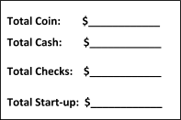
Nickels $__________ Fives $__________
Dimes $__________ Tens $__________
Quarters $__________ Twenties $__________
Other $__________ Other $__________

Checks
Number Amount Name
_____ $_________ ________________________________
_____ $_________ _________________________________
_____ $_________ _________________________________
Signature #1 ____________________________ Signature #2 ________________________

Closing

Coins Amount Bills Amount
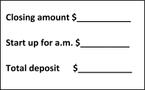
Pennies $__________ Ones $__________
Nickels $__________ Fives $__________
Dimes $__________ Tens $__________
Quarters $__________ Twenties $__________
Other $__________ Other $__________

Total Coin: $__________ Total Cash: $__________

Checks
Number Amount Name
_____ $_________ _________________________________
_____ $_________ ________________________________
_____ $_________ ________________________________

Signature #1 _____________________________ Signature #2 _________________________

Defenders’ Café Weekly Deposit Log
Week Ending ___________
Weekly Sales:
Elementary High School
Monday $____________ $___________
Tuesday $____________ $___________
Wednesday $____________ $___________
Thursday $____________ $___________
Friday $____________ $___________

Total: $_____________

Receipts For Supplies:
Vendor Amount
_________________________________ $____________
_________________________________ $____________
_________________________________ $____________
_________________________________ $____________
_________________________________ $____________

Total: $_____________

Total Deposit for Week: $_____________

Notes: __________________________________________________________
____________________________________________________________________________________________________________________________________________________________________________________

